Press Kit

July 9th, 2019

Written and performed by
Chris Gibbs

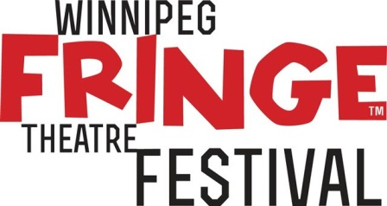
Winnipeg Fringe Festival
Venue 4
RIO – Portage Place
393 Portage Ave. (Portage Place 3rd Floor)
Thu, Jul 18 - 12:00 PM Tue, July 23 - 3:30 PM
Sat, Jul 20 - 6:45 PM Thu, July 25 - 8:30 PM
Sun, July 21 - 5:30 PM Sat, July 27 - 3:30 PM
Mon, July 22 - 5:45 PM Sun, July 28 - 7:00 PM

Media contact : Chris Gibbs
647 654 3930
mail@chrisgibbs.ca
www.notquitesherlock.com
www.chrisgibbs.ca
Not Quite Sherlock
RELEASE

Chris Gibbs
647 654 3930 www.notquitesherlock.com
mail@chrisgibbs.ca www.chrisgibbs.ca

FOR IMMEDIATE RELEASE
July 9th, 2019 - Please include in your listings.

NOT QUITE SHERLOCK : AWARD-WINNING COMEDIAN AND FRINGE VETERAN CHRIS GIBBS HASN’T DONE THE FRINGE FOR A WHILE, BUT WAS IN A STEVEN SPIELBERG MOVIE, SO THAT’S COOL, RIGHT?

It’s been 5 years since British comedian Chris Gibbs last played at the Winnipeg Fringe. Since then he has toured throughout the rest of Canada with various one-man shows; directed several plays, including the 2016 Winnipeg Fringe hit ‘In Search of Cruise Control’; appeared in an episode of CBC’s Murdoch Mysteries; and fulfilled every actor’s dream - working with Steven Spielberg. Chris played one of the evil giants in the Disney live-action movie, The BFG. And that’s nice isn’t it.

London, 1896. Barnaby Gibbs is an incurable optimist, a Sherlock Holmes fan, and a man who knows he’s not good at anything. One night, while checking on a friend's empty house, he encounters a stranger, dressed entirely in black, holding a bag full of stolen belongings and attempting to write a poem about sapphires. There is only one conclusion a reasonable man could come to: this is the notorious cat burglar known as the Rhyming Bandit! Fortunately, Barnaby Gibbs is not a reasonable man, and when the stranger explains he is actually the famous detective Antoine Feval, a new crime-fighting duo is born.

Not Quite Sherlock is a one-man play about Victorian London’s most overlooked detective. It's also a ridiculous comedy about an ex-street-performing comedian attempting to do a one-man play about Victorian London's most overlooked detective. With wit, charm, timing, and almost no respect for the rules of theatre, Chris Gibbs creates a simple, hilarious theatrical experience unlike any other.

Under its original title ‘Antoine Feval’, Not Quite Sherlock premiered in the 2005 Winnipeg Fringe, where it won Best of Fest. The show won the Just For Laughs Best Comedy award at the Montreal Fringe in 2009. It’s since been performed all over Canada and a little bit beyond - including the High Performance Rodeo in Calgary, the Uno Festival in Victoria, the Revolutions Festival in the US, and The World Buskers Festival in NZ.

Chris Gibbs is the creator of the past fringe hits ‘Gibberish’, ‘Like Father, Like Son? Sorry’. ‘The Power of Ignorance’ (co-written with TJ Dawe) and the sequel to Not Quite Sherlock, ‘The Further Adventures of Antoine Feval’. He’s been described as ‘One of the funniest guys around’ by the National Post and ‘effing brilliant’ by Now Toronto’s Glenn Sumi.

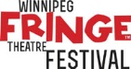
Not Quite Sherlock at the Winnipeg Fringe
Venue 4, RIO – Portage Place, 393 Portage Ave. (3rd Floor)
Thu 18 @ 12:00 PM
Sat 20 @ 6:45 PM
Sun 21 @ 5:30 PM
Media contact : Chris Gibbs
647 654 3930
mail@chrisgibbs.ca
www.notquitesherlock.com
www.chrisgibbs.ca

Mon 22 @ 5:45 PM
Tue 23 @ 3:30 PM
Thu 25 @ 8:30 PM
Sat 27 @ 3:30 PM
Sun 28 @ 7:00 PM
Tickets $12
winnipegfringe.com
Synopsis

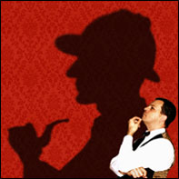
London, 1896. Barnaby Gibbs is an incurable optimist, a Sherlock Holmes fan, and a man who knows he’s not good at anything. One night, while checking on a friend's empty house, he encounters a stranger, dressed entirely in black, holding a bag full of stolen belongings and attempting to write a poem about sapphires. There is only one conclusion a reasonable man could come to: this is the notorious cat burglar known as the Rhyming Bandit! Fortunately, Barnaby Gibbs is not a reasonable man, and when the stranger explains he is actually the famous detective Antoine Feval, a new crime-fighting duo is born.

Company Bio: Chris Gibbs

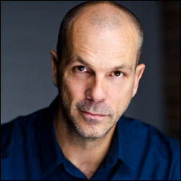
British comedian Chris Gibbs has been described as “One of the funniest guys around” by the National Post. The Toronto Star has called his shows “darkly gleeful” and “comic stand-up gold”; and the CBC has described his delivery as “a combination of dry wit and barely controlled madness that threatens to go off the rails at any time”. He is best known for the one-man comedy shows which he performs all over Canada and beyond. But that’s not all! He’s played at Just For Laughs in Montreal, appeared in two CBC Winnipeg Comedy Festival Galas, starred in the indie Canadian feature film, ‘Run Robot Run’ and is even a published author. He’s won two Canadian Comedy Awards, Best Improv Troupe with ‘The Carnegie Hall Show’ and Best Comedic Play with ‘Plan “Live” From Outer Space’. In 2015 he played "Gizzardgulper", one of the evil giants in the Disney feature ‘The BFG’, directed by Steven Spielberg. Other on-screen credits include roles in ‘Murdoch Mysteries’, ‘Odd Squad’, ‘Copper’, and ‘The Samaritan’.

Chris started his comedy career in 1991, working as a street performer in London’s Covent Garden. Combining comedy with acrobatics, he spent several years on the street honing his skills; while also performing in stand-up and improv shows around London.
In 1993 he teamed up with Peter Mielniczek to form the physical comedy duo ‘Hoopal’. They were quickly invited to perform in theatre, street and comedy festivals throughout Europe, and as far afield as Australia, New Zealand and Canada. Hoopal is possibly best summed up by this quote from one of their first reviews; the Capital Times, in Wellington, NZ said - “it’s stupid, nonsensical, indulgent, pathetic and insulting to the intelligence… I loved it!”

Chris moved to Canada in 2002 and immediately began writing and performing one-man shows. These include two plays about Victorian London’s most overlooked detective - ‘Not Quite Sherlock’ and ‘The Further Adventures of Antoine Feval’; as well as the stand-up comedy shows ‘A Legal Alien’ and ‘Like Father, Like Son? Sorry’, and the spoof motivational seminar ‘The Power of Ignorance’ co-written with fringe legend TJ Dawe.

Chris has directed a number of other acclaimed shows, including James Gangl’s Canadian Comedy Award-winning one man show 'Sex, Religion and Other Hang-Ups' as well as ‘In Search of Cruise Control’.

Photos:

Download hi res images at notquitesherlock.com/presskit

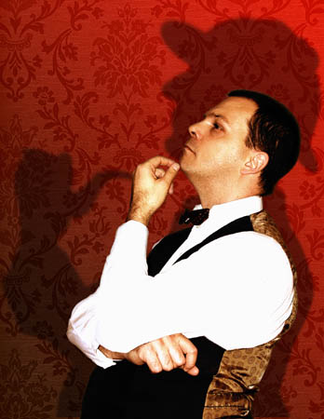

Press quotes:

“Gibbs’s performance is near flawless. His martini-dry wit is characteristically sharp, and his comic timing is beautiful.”
CBC

“Clueless, guileless and absolutely priceless…Sherlockians will be in heaven. Everyone else will be here, laughing hard.”
Edmonton Journal

“a masterpiece that manages to be both ridiculous and intelligent”
Vancouver Sun

“full of twists, turns, and gadzooks moments.”
Now Magazine, Toronto

“a highly skilled, confident comic actor whose writing is unrelentingly clever and whimsical”
Victoria Times Colonist

“one of the most cleverly written and performed shows I’ve ever seen at the Fringe.”
stage-door.com

